**AWS Practise Lab 2 - Submitted by Sri Ananya Kondiparthy**

1. Create a redshift cluster on your AWS account. Verify you are able to access Redshift database from Pentaho and Tableau using appropriate drivers and connection strings

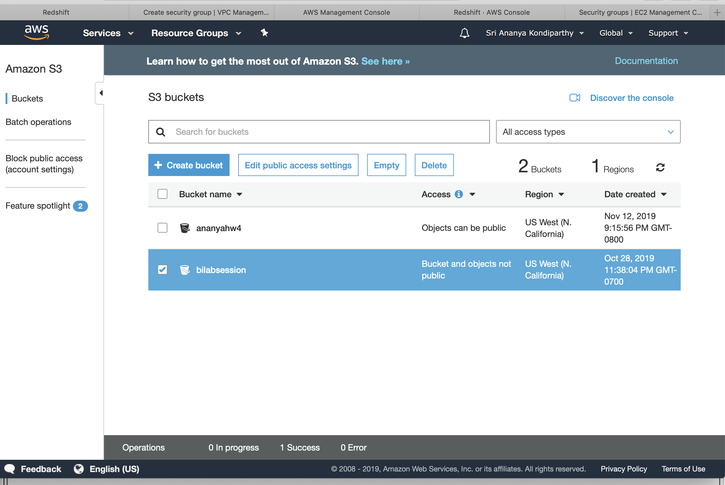

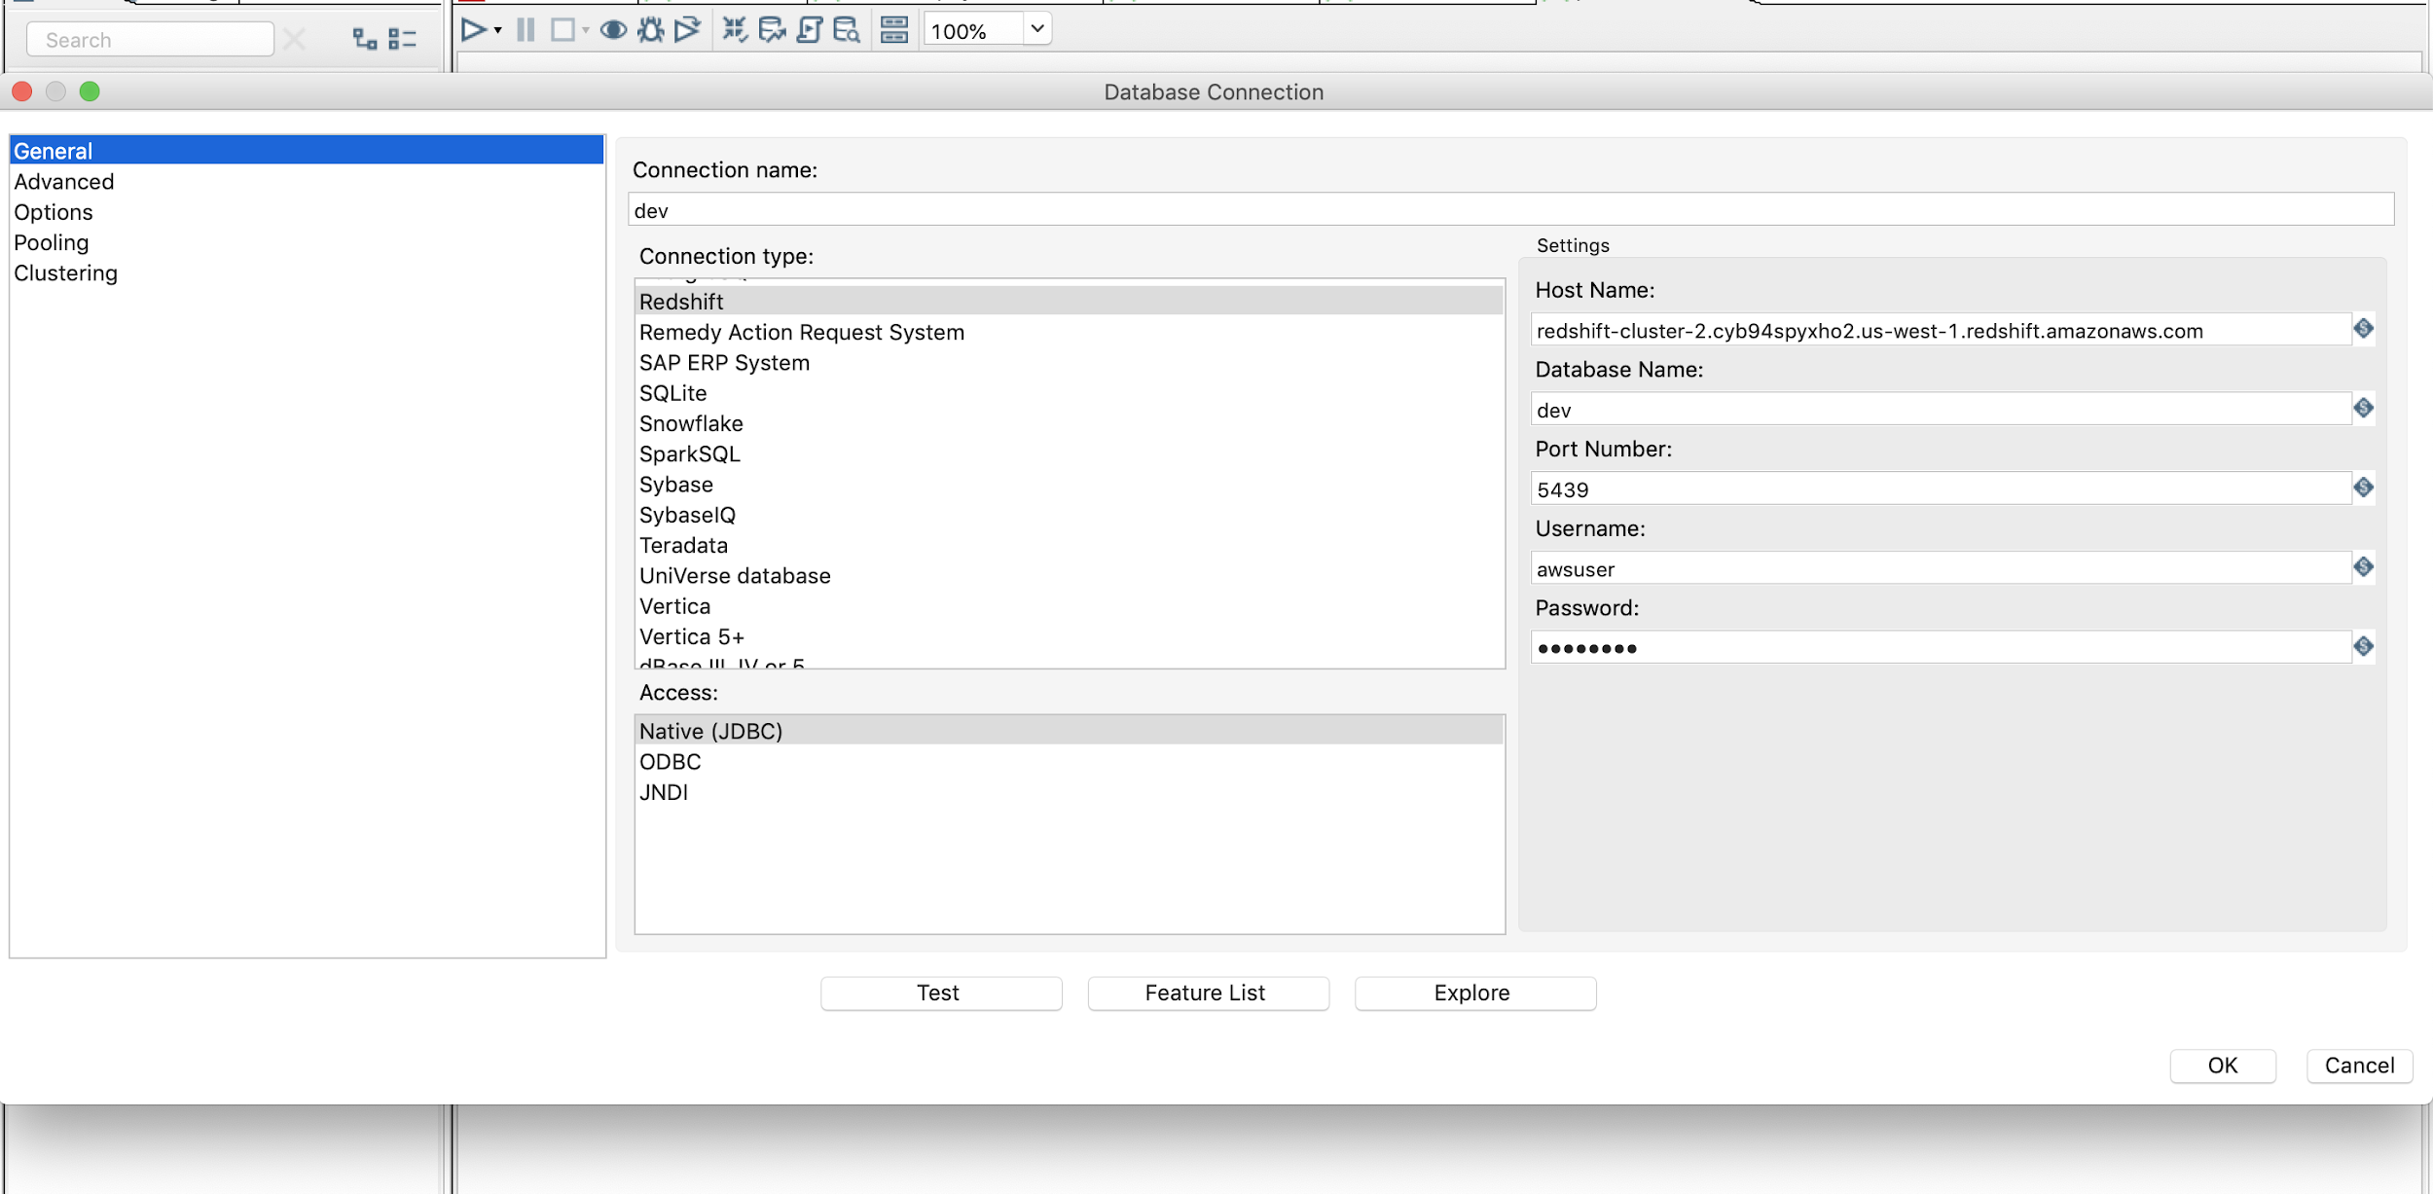

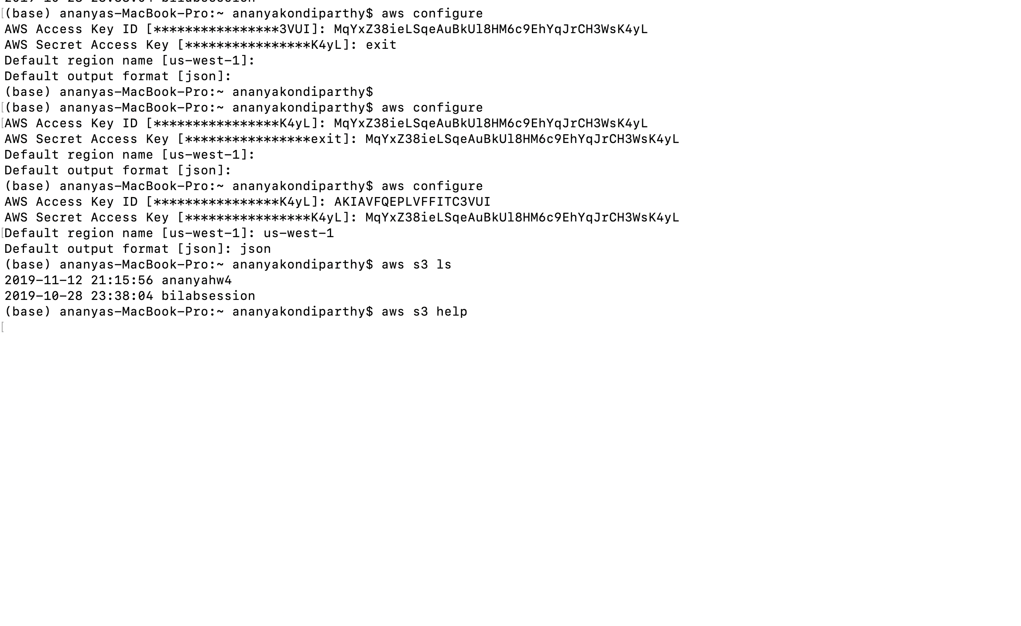

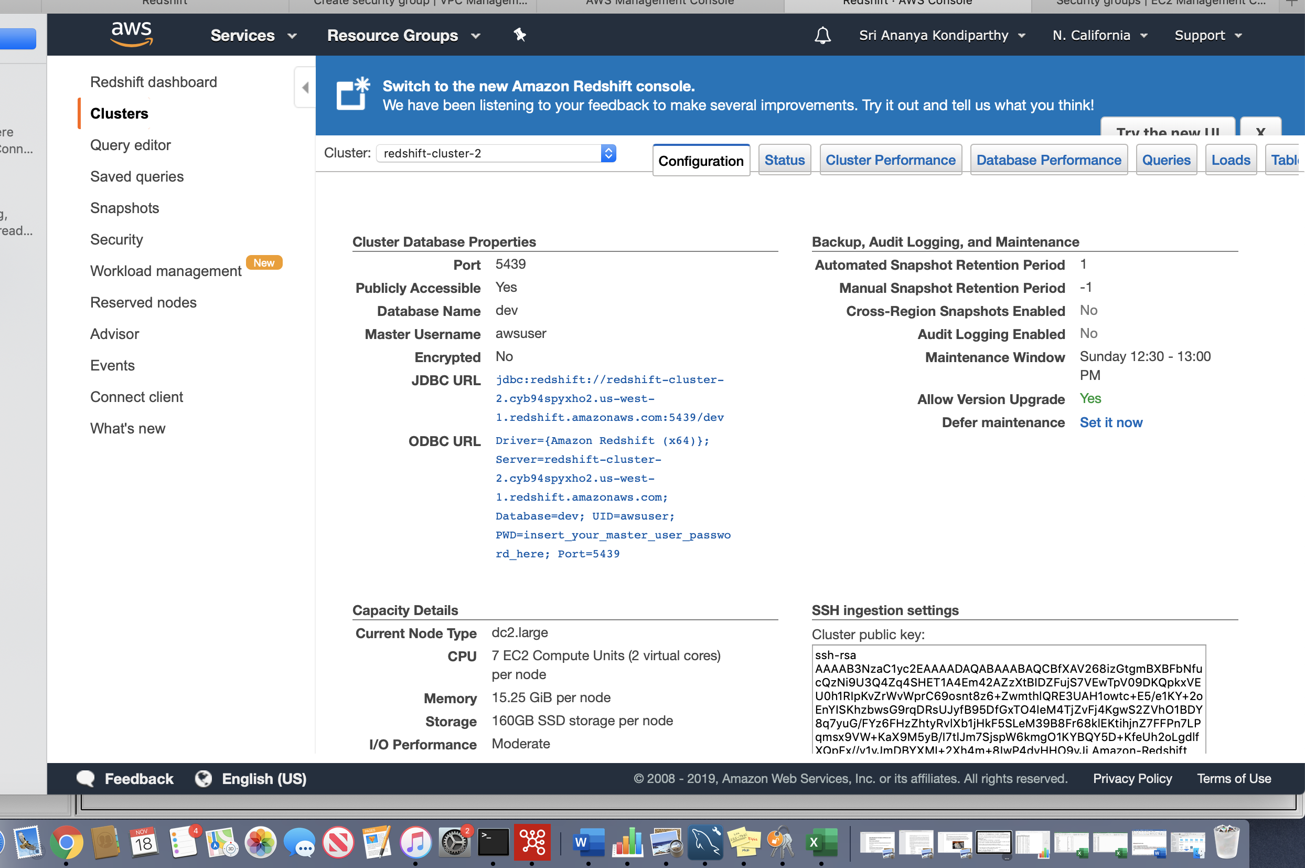

Upload the CSV file to S3 using AWS Client

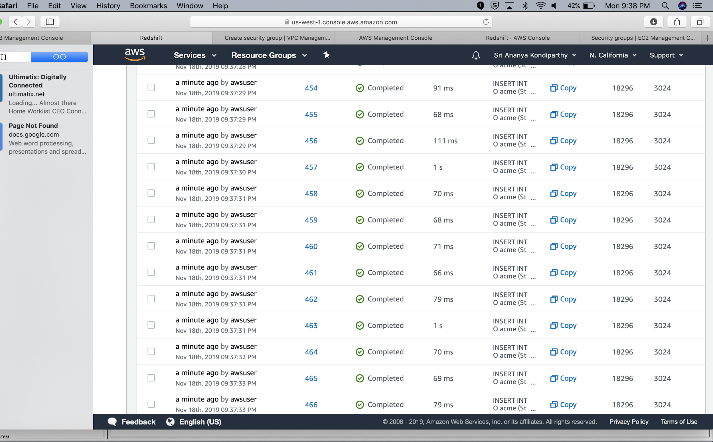

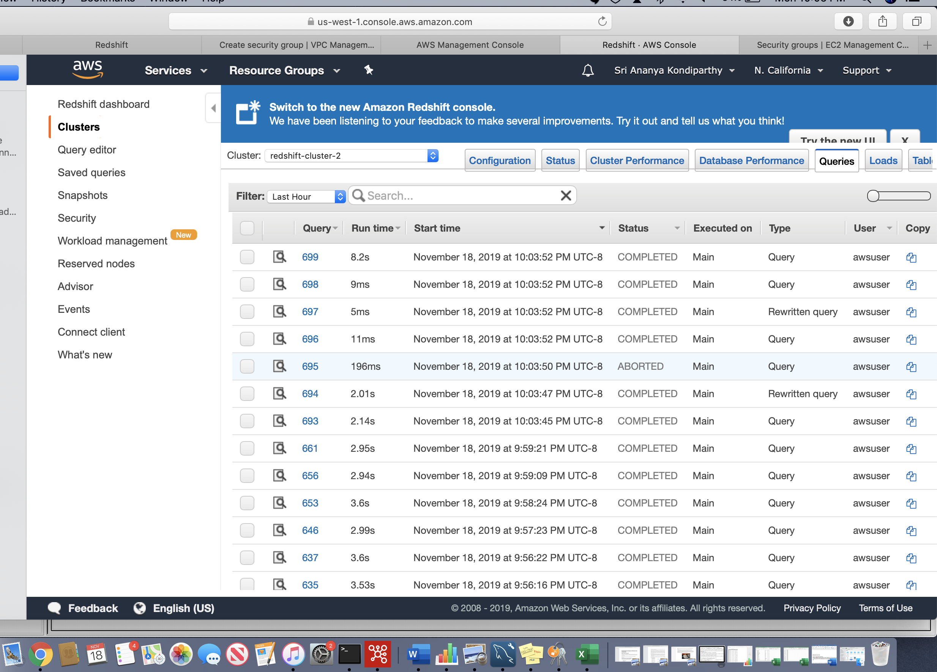

Use Pentaho to read CSV file from S3 and load data to Redshift

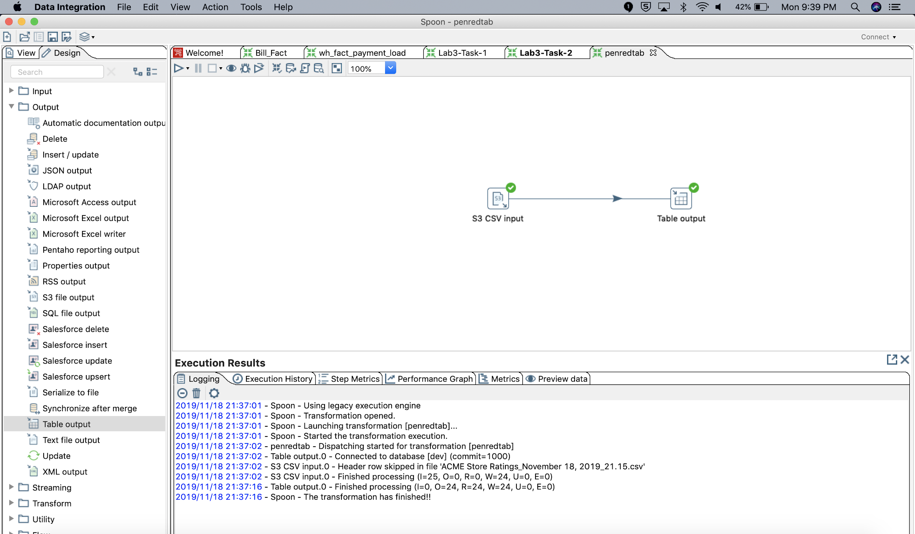

Use Tableau to connect to Redshift to generate following report

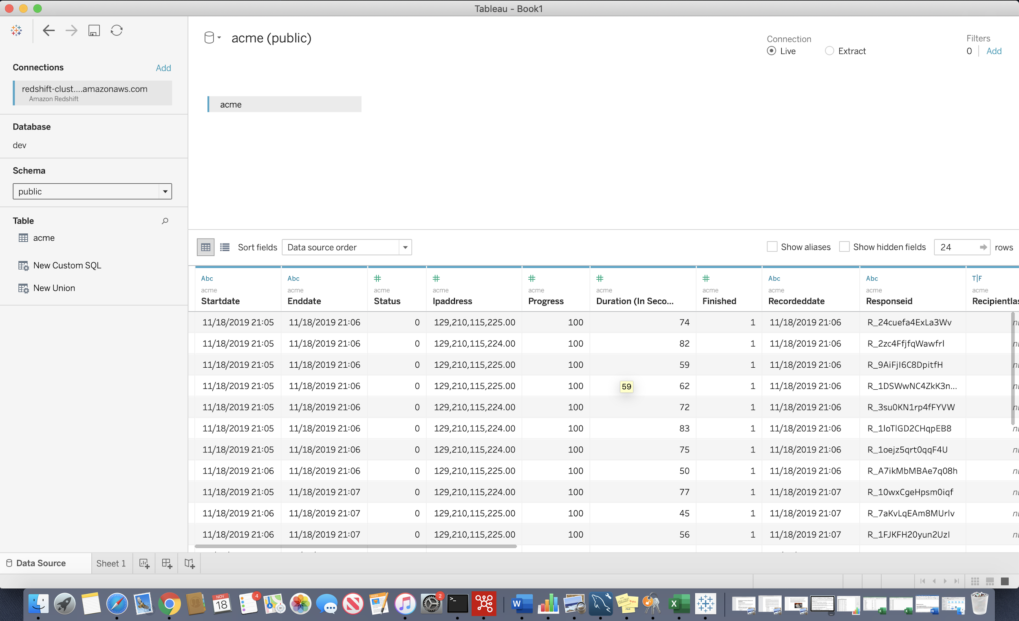

Average Rating by Store, Month, Age Group

Age Group should be shown as 20-30, 30-40, 40-50. Implement this transformation as your feel appropriate.

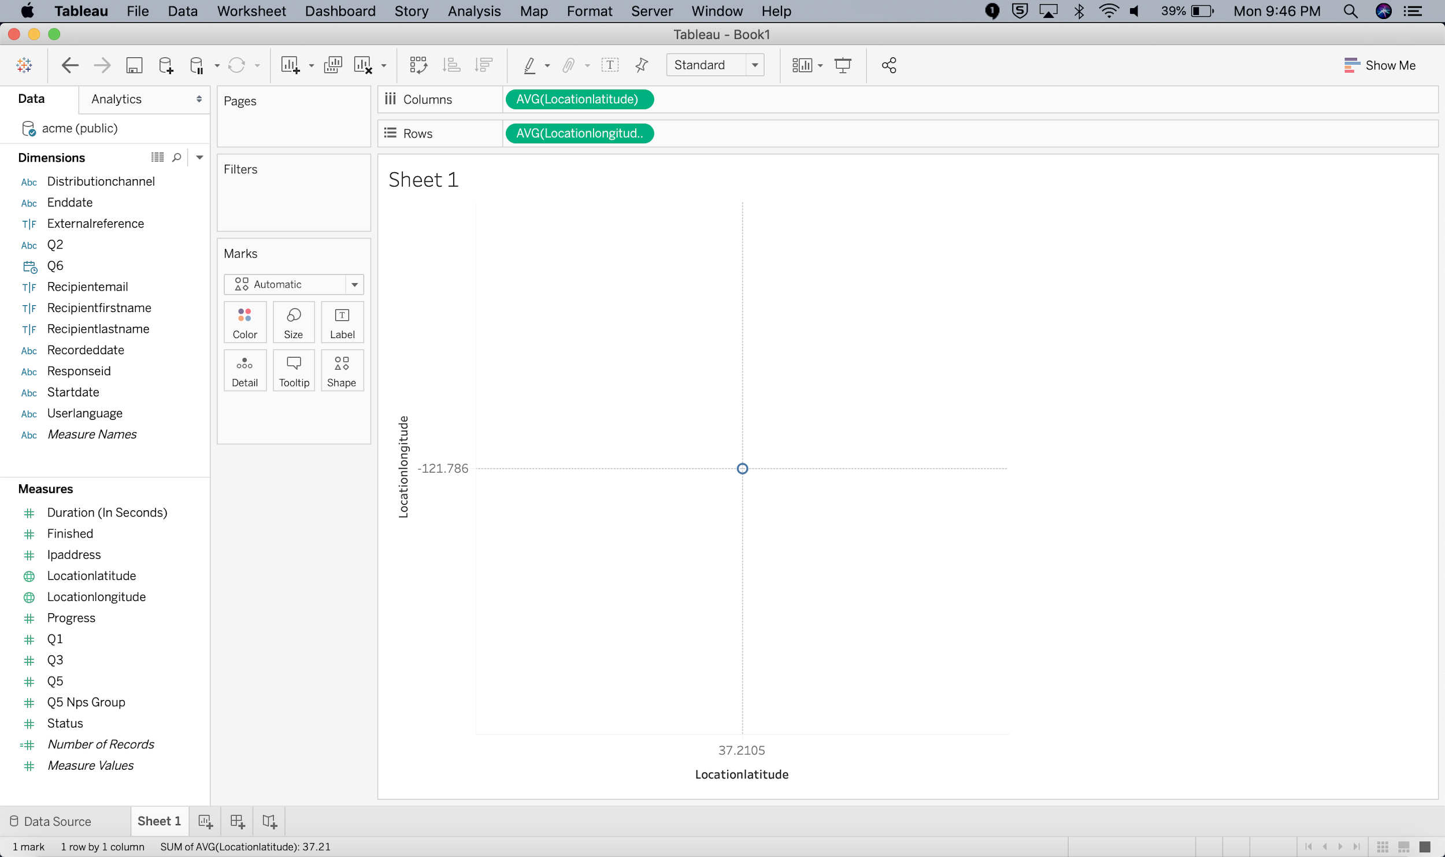

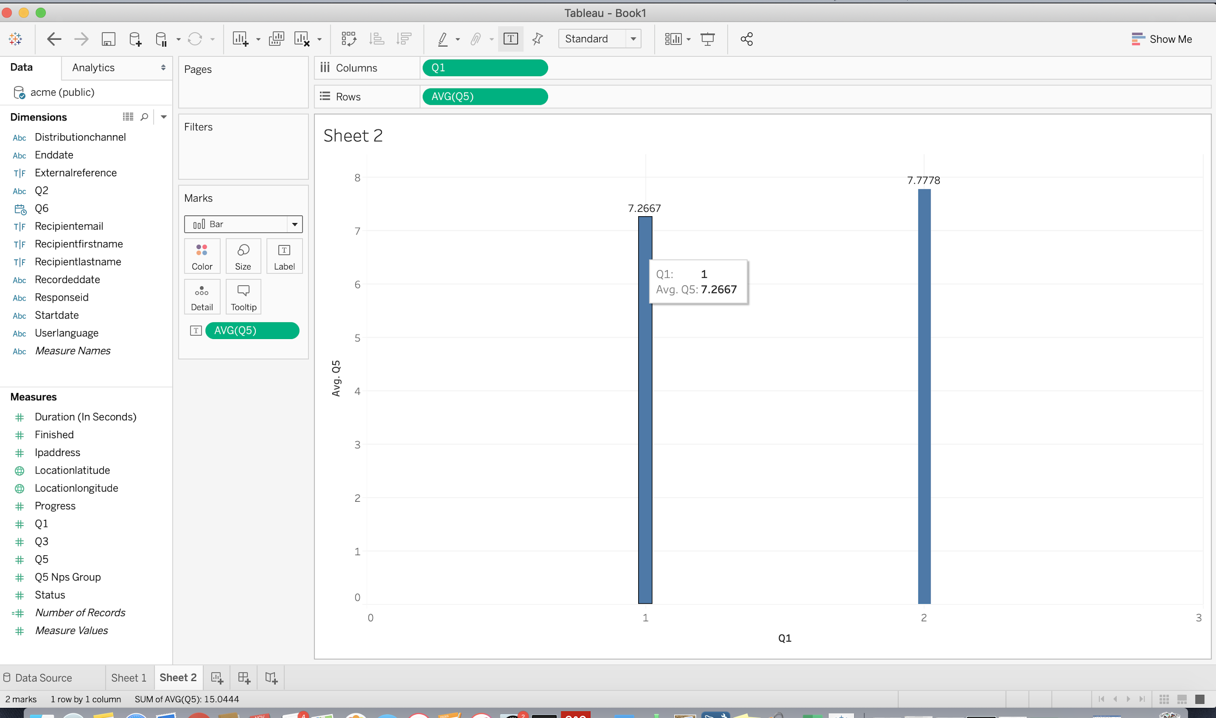

The Average Rating by Store and month

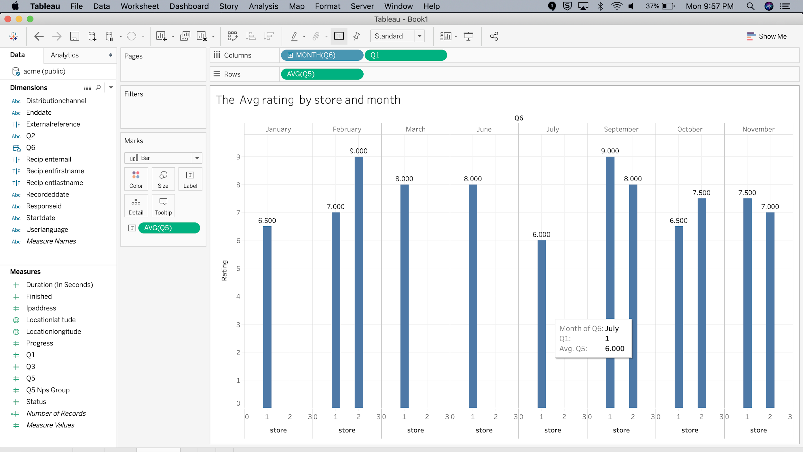

The Avg Rating by store, month and age

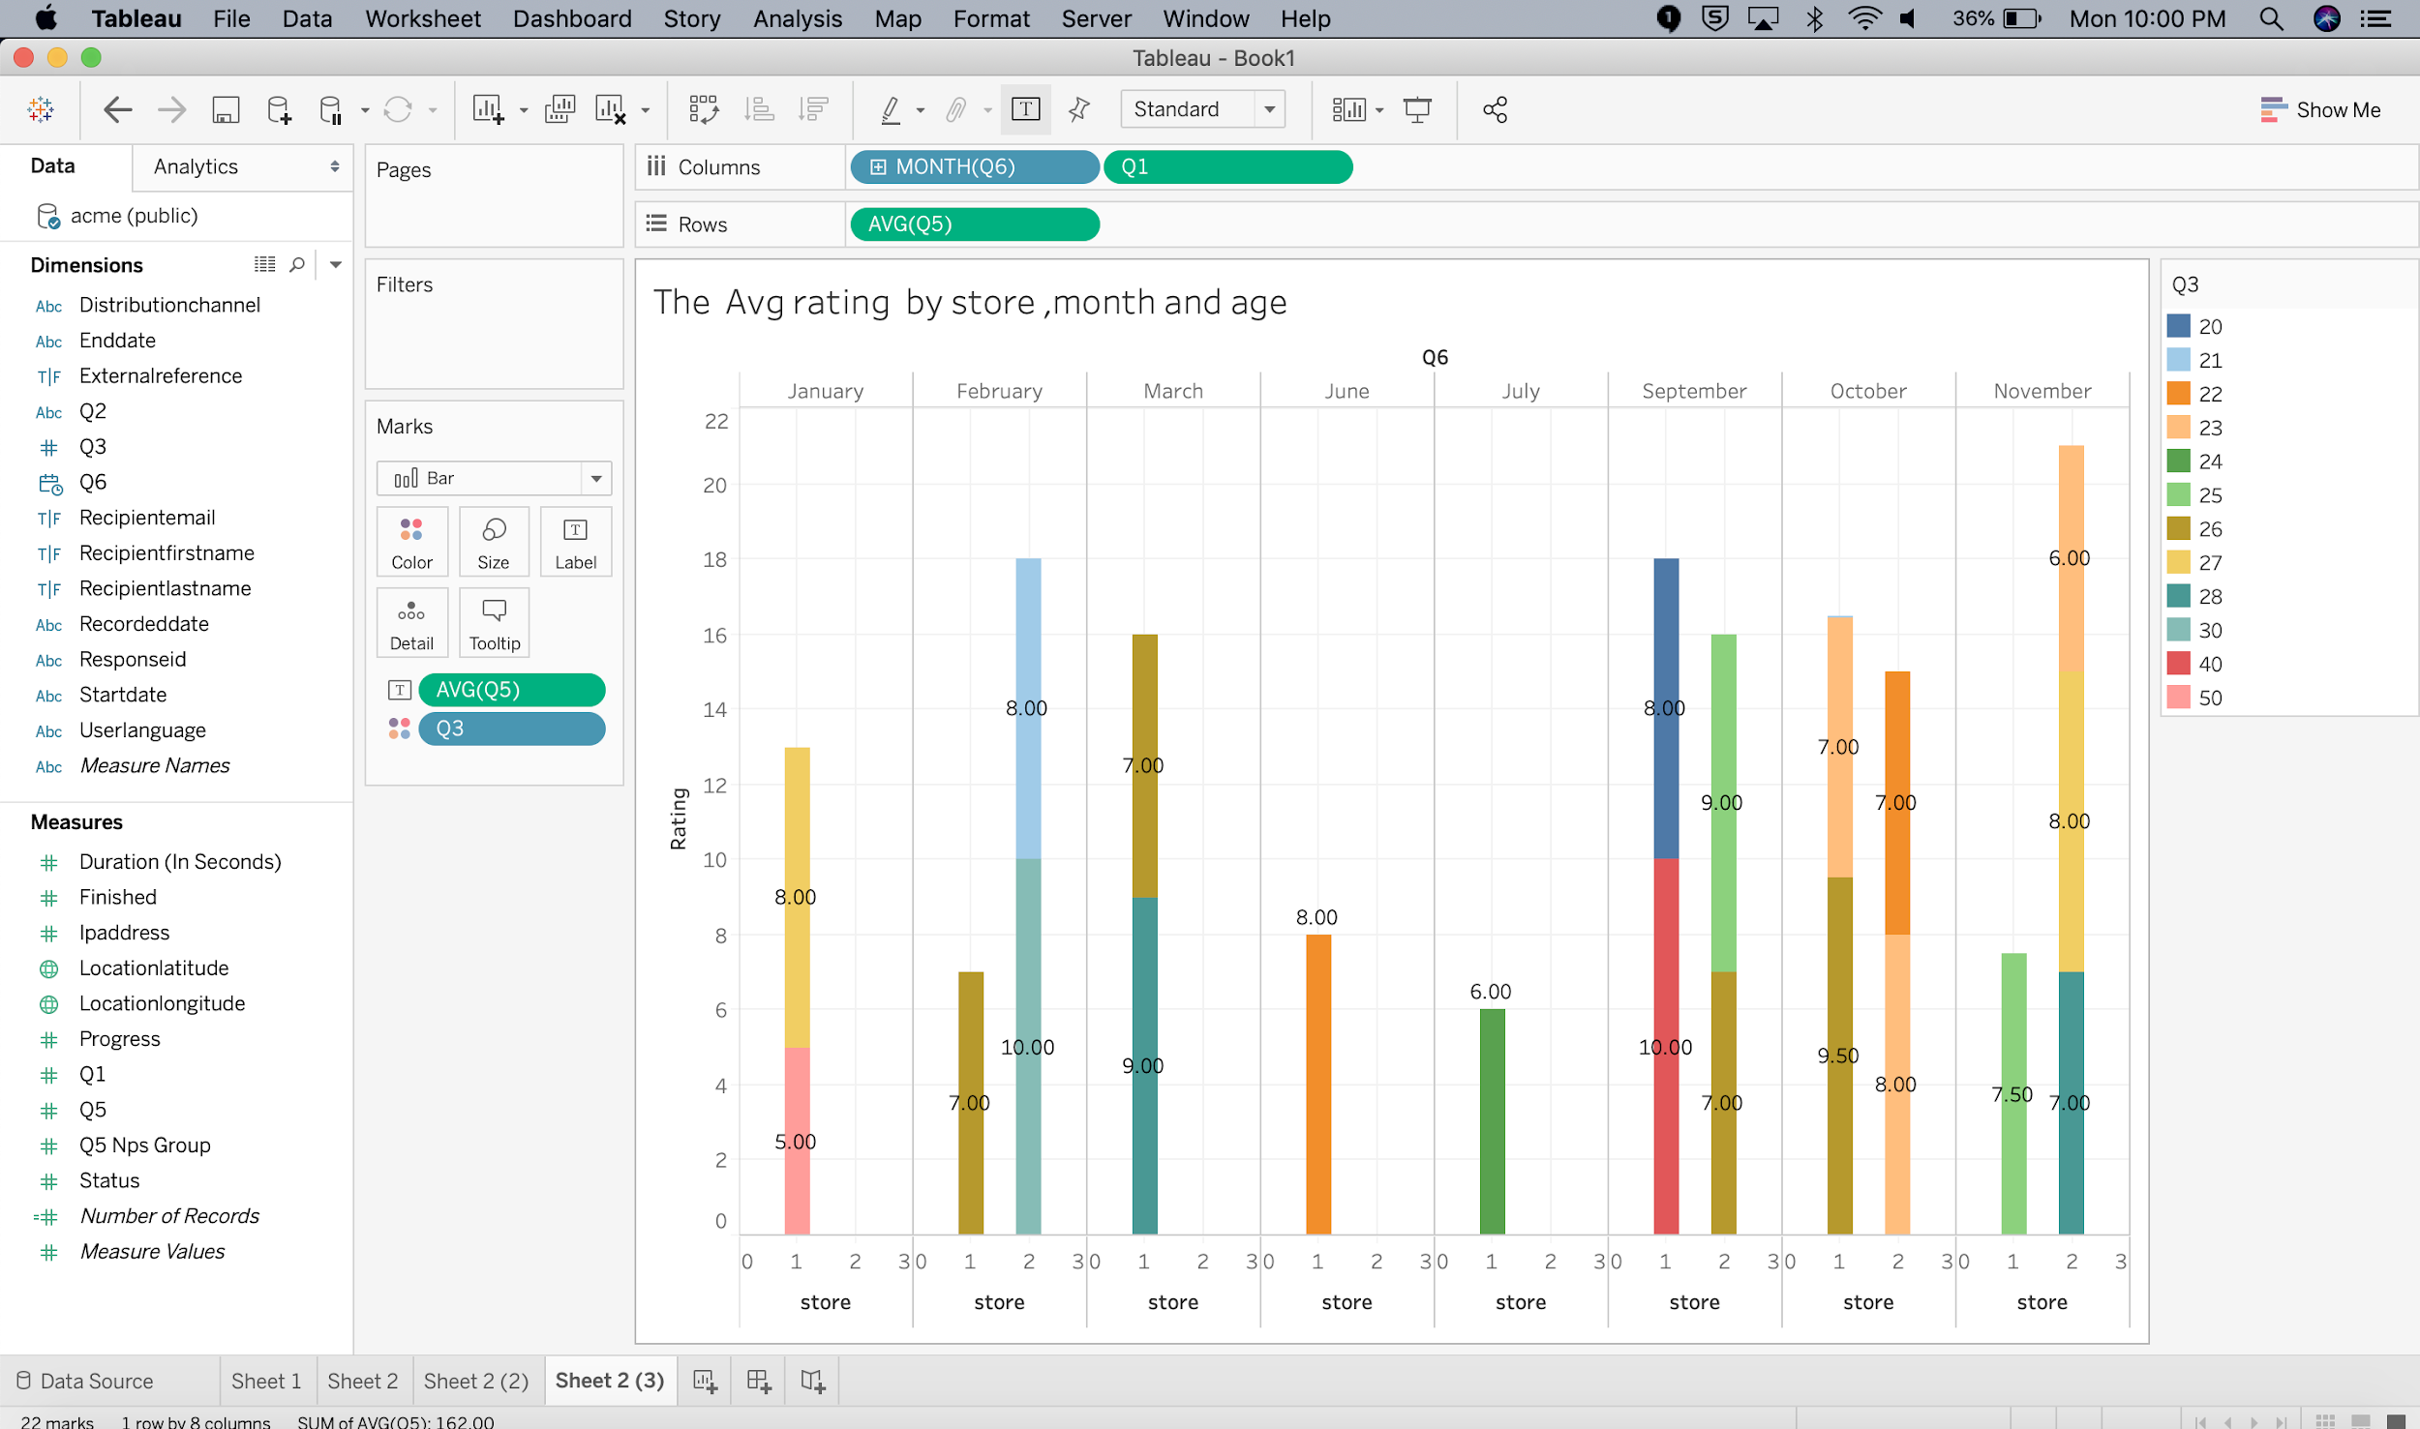

The Average Rating by store, Month and age in the age group segregation 20-30, 30-40 and 40-50

